Exception Handling In JAVA

Topic to be covered

1-What is Exception Handling?

2-Error VS Exception

3-Exception Hierarchy

4-Checked VS Unchecked Exception

5-Basic Exception Example

6-Types of Exceptions

7-Exceptions Method

8-Throw VS Throws

9- final VS finally VS finalize

1\*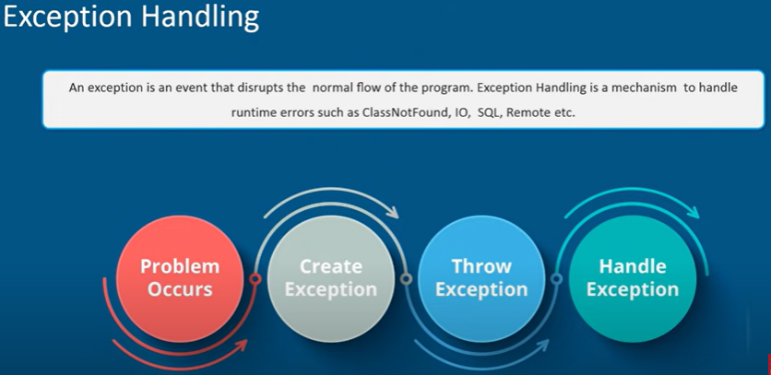

2\*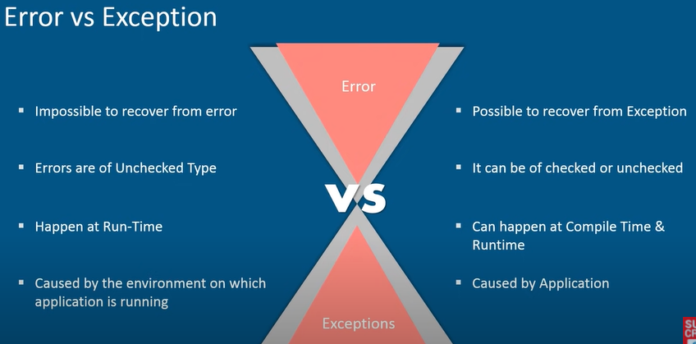

3\*

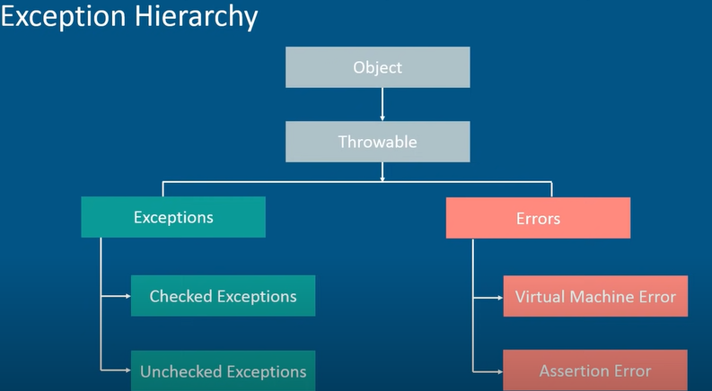

4\*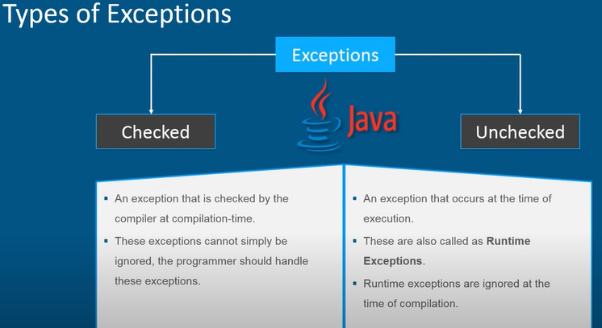

5\*

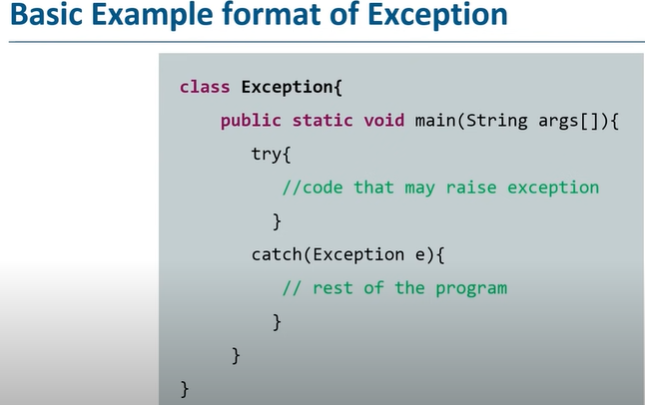

6\*

This program will give exception because string is null.

Then also we are trying to get the length of the string.

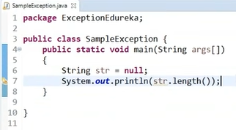

7\*

8\* Types of Exceptions

1-Built-in Exceptions

2-User Defined Exceptions

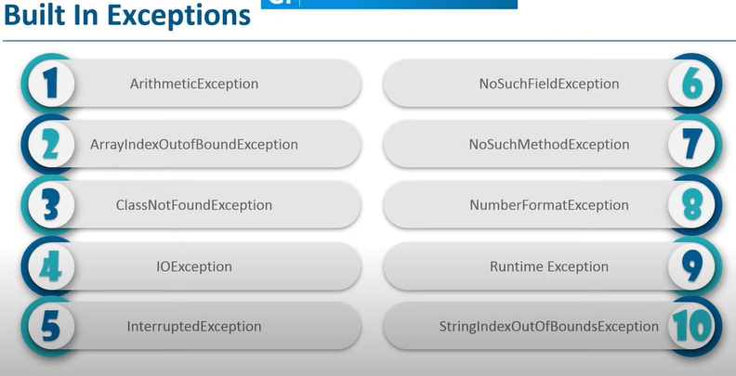

Examples

-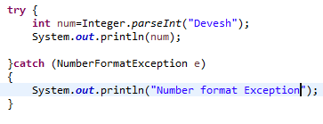 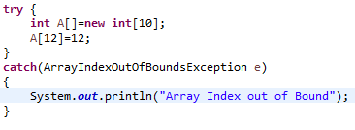

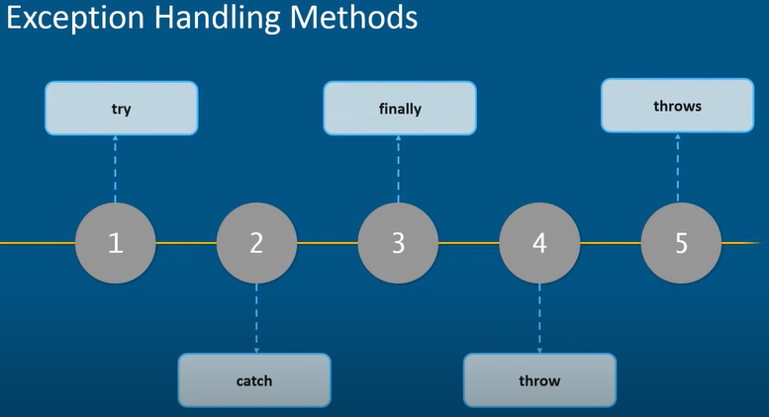

EXCEPTIONAL HANDLING TYPES

1-try

=>

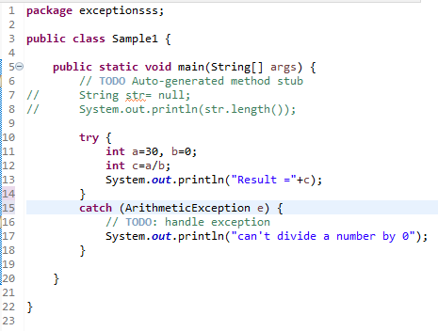

2-Nested try

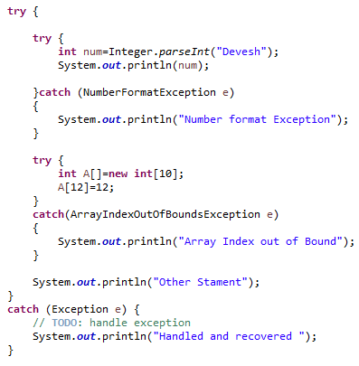

3-catch block



4-Multi Catch

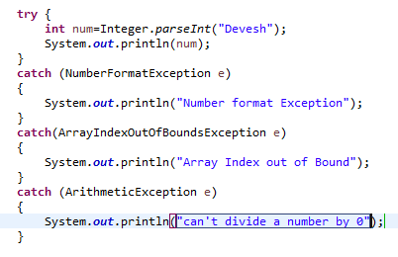

5- Finally

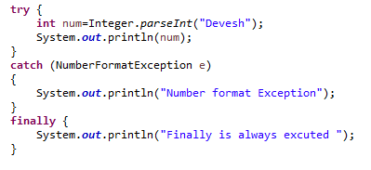

6-Throw

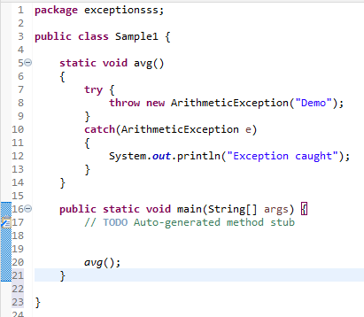

7-Throws

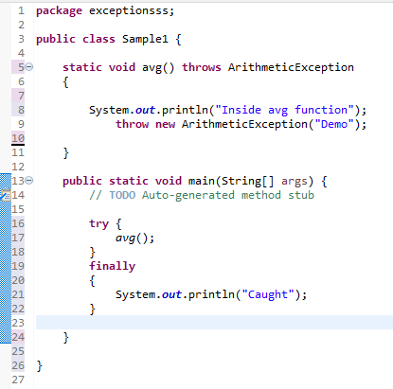

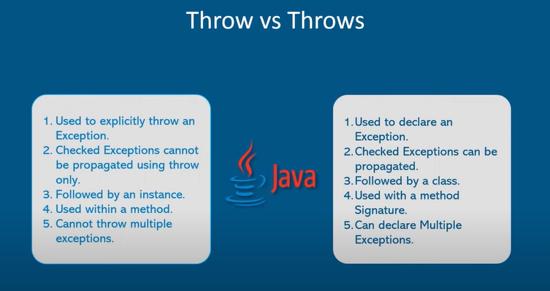

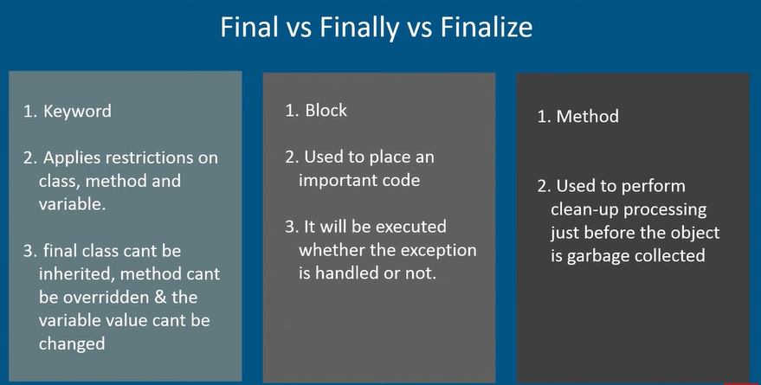

User Defined Exception

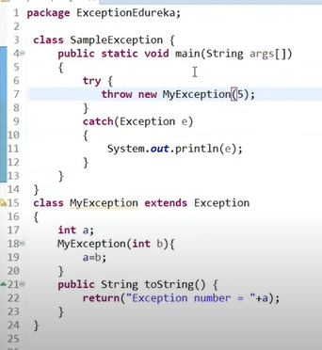

Parsing an Exception

